Ideation Phase

Define the Problem Statements

Date | 15 February 2026
Team ID | 216
Project Name | Visualizing Housing Market Trends: An Analysis of Sale Prices and Features using Tableau
Maximum Marks

Customer Problem Statement Template:
Create a problem statement to understand your customer's point of view. The Customer Problem Statement template helps you focus on what matters to create experiences people will love.
A well-articulated customer problem statement allows you and your team to find the ideal solution for the challenges your customers face. Throughout the process, you’ll also be able to empathize with your customers, which helps you better understand how they perceive your product or service.

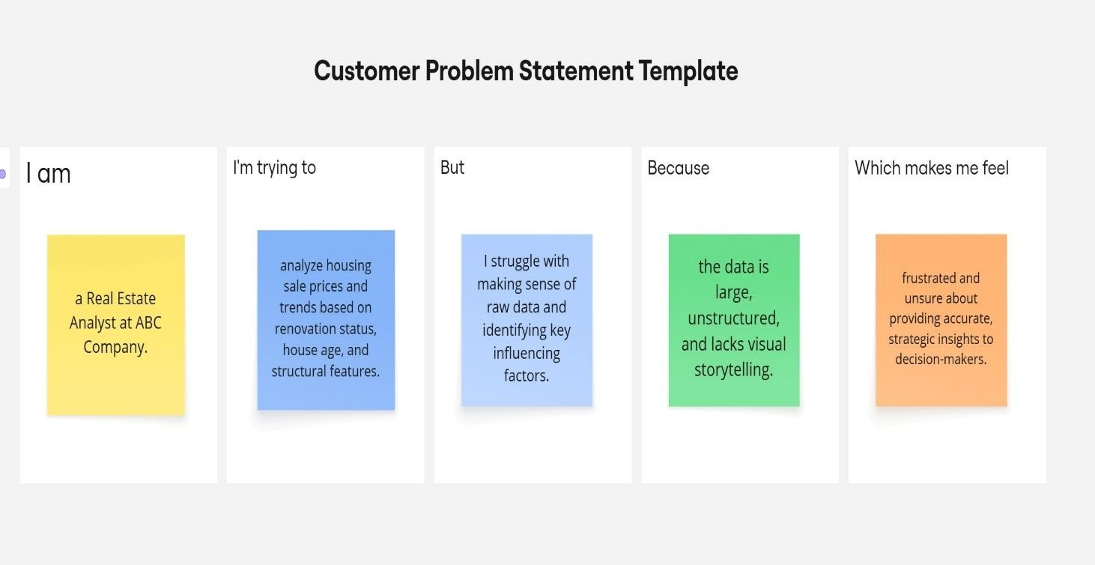

Problem Statement  (PS) | I am (Custom  er) | I’m trying to | But | Because | Which makes me  feel
PS-1 | a Real Estate Analyst at ABC Company | analyze housing sale prices and trends based on renovation status, house age, and structural features. | I struggle with making sense of raw data and identifying key influencing factors. | the data is large, unstructured, and lacks visual storytelling. | frustrated and unsure about providing accurate, strategic insights to decision-  makers.
PS-2 | a Company Executive at ABC Company | make data- driven decisions to optimize housing pricing strategies. | I cannot easily interpret detailed data or compare features like bathrooms, floors, and renovations. | traditional reports are too complex and not visually accessible. | disconnecte d from the real trends in the housing market and hesitant to make confident  business decisions.

